Anjum Jalal Shaikh

|  |  |
| --- | --- |
| **6300790526**  **Pune** | [taamulani25@gmail.com](mailto:taamulani25@gmail.com) |

# Summary

Results-driven Full Stack Developer with 2+ years of experience, specializing in both frontend and backend development. Proficient in creating responsive, user-friendly web applications. Strong background in UI/UX design and API integration. Adept at translating business requirements into high-quality code.

# Skills & Abilities

* Proficient in HTML5, CSS, and JavaScript (ES6).
* Experience with Git for version control and collaboration.
* Familiar with AWS services specifically EC2.
* Proficient in C,C++,Java

·

# Professional FRONT END DEVELOPER | MINDLABZ SOFTWARE SOLUTION

**Experience**

**Frontend Developer (JUNE 2021 -Current):** - Developed interactive and responsive user interfaces using Javascript, HTML5,bootstrap and CSS.

# Intern (JUN 2021 – DEC 2021 ): -

* + Participating in software development projects.
  + Participating in code reviews.
  + Provided support and maintenance for existing websites.
  + Developing user interface as per requirements which are responsive.

# Projects

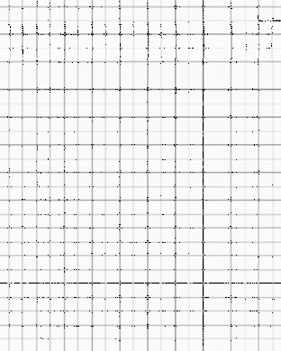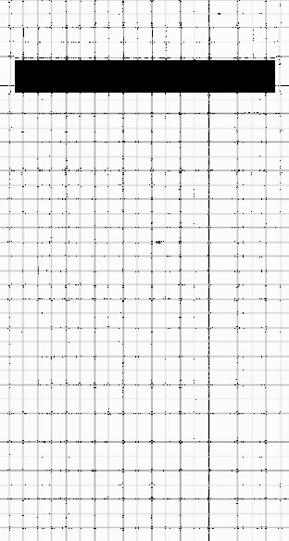

**BANK CASHSLIP:**

# Full Stack Developer

Designed and developed a web application to generate cash deposit slips for banks. No need to visit bank to fill up cash slip, it will done online using this app. It provide multiple bank in this app to fill online cash slip.

|  |  |  |  |
| --- | --- | --- | --- |
|  |  | |  |
|  | **Roles and Responsibilities:**   * Created an intuitive frontend interface using Html,Css,Javascript allowing users to input transaction details. * Designed and developed a web application to generate cash deposit slips for their respective banks. * Integrated third-party libraries for PDF generation and implemented data validation for accuracy.   **Technology Used:** html5, Css, Bootstrap,Javascript and MySql. |  |
| **Professional Summary** | Currently working in Mindlabz Software Solution Pune as Jr. Frontend developer Having 2+ years of experience as Frontend developer. Experience in working in website development and designing. |  |
| **Education** | **Bachelors of Engineering:** GHRCEM Pune  **67.19%**  **Diploma:** Government Polytechnic Ahmednagr.**72%**  **SSC:** Shree uttareshwar high school kem.  **85.23** |  |
| 2 | |  |



|  |  |  |  |
| --- | --- | --- | --- |
|  |  | |  |
| **Languages** | English Marathi Hindi |  |
| 3 | |  |

